Are you aware of the insidious nature and mis-assumption based structures of the perceptual processes that you are currently unaware of in you, but that already consistently affect you in unsupportive, negative or disruptive way? As you become consciously aware that there are processes going on within your mind that you were unaware before, no truly intelligent person will settle any longer for fighting against it, or settling for how their perception currently is. And as you become consciously aware of your growing need to evolve beyond your current conflicts and struggles, you will naturally realise that what I am offering here is truly what you need, and you will look back in the future and realised that getting this information was the day your life changed forever for the better, and you can finally experience the peace and happiness you deserve. You will naturally experienced balance, peace and happiness, when your mind sees and acknowledges what causes its own conflict, hurt and suffering, and your mind naturally let's go of indulgence in the structures and strategies within its own perceptual calculations. Once you really see how this works, you will easily see the benefits of what is being taught here, and what comes with it. After you have read this book, you will undoubtedly understand more.

I'm sure you realise, or you will by the time this video is finished, that etc. etc.

Once people just like you, realise X, they get really excited and must have it.

Just before you decide (pause) how easy it is to (pause) make this decision, let me tell you something that will make that even quicker etc. etc.

Ask what do they want?

If your audience are not looking at you in a video, have a screen change about every 10 seconds.

Remove all filler words by holding your hands to your ears and this will allow you to listen to your own words and where you would um or er, and pause with no words instead. This also helps to cut down on editing. It's called dynamic listening.

I'm not happy
This is why
This will make me happy.

I'll show you a step-by-step way to do with the way you want.
Purpose - Goals – Plan – Actions – Feedback (int and ext) – Adjust.

Yet people to ask for things (so you're not just sending them to them) mailing list or direct mail etc.
Promotion - Free Report- Invite.

Free report (away motivated)
product towards resolution motivated

Six stage scripting system - Peter Thompson:
- Perspective (make a report on each mistake or all mistakes) (" as you and I know".
- Problem (let me explain what you and I know the problem to be).
- Pain (what is the relative, related perceived pain for this issue).
- Possibilities (possible solution - what could be different).
- Pleasure (what this can help you avoid, achieve, retrieve her experience).
Plan (here's the plan).

“Do you make these 7 critical mistakes” - Best headline ever!

“Turns your ?? into ???”

Go through all copyright and change any verbs 'to be' into 'is' and' to be will' into 'when'.

Curiosity drives people to ask for your stuff. Get them curious, don't give it all to them, but give them good stuff, if not your best.

Unwitting is a better word than unwittingly.

Use blind bullets - create curiosity.
- The number one way to get your dog to come back every single time.
- The number one question people ask that accountants get wrong.
- The number one question running around in people's mind, and they don't even know.

Talk about the cleaning out process of the overall calculation, the calculation is getting smaller.

Talk about the line that rises as the fluctuation of moods get smaller and smaller.

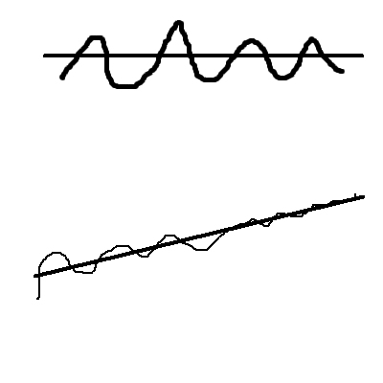

Conscious intelligence consists of the deliberate observational process of awareness - recognition - acknowledgement - observe any reactive hostility ( offering towards self) - contemplation - clarity - understanding - new choice. All this is under the umbrella of already knowing how you want to feel moment by moment (peaceful, balanced, happy except), so you know what choices to make to bring that about during or after any situation or circumstance.

Teach the art of contemplation.

Self-criticism is probably the only strategy for change you have been taught, so it isn't naturally what is used to attempt to create change and growth. However it does not work to create growth, only discomfort and self disappointment.

Do you see the potential for success, or do you see the potential for threat? The mind is an expert on threat avoidance, especially perceived threat avoidance.

This book is not about change; it is about seeing the true perceptual processes going on in you, and through true awareness and intelligent choices, speeding up the evolutionary progress of genuine perceptual growth towards conscious evolution and true peace. Constant perceptual evolution 'is' perfection. This book is not teaching you how to think differently. It is attempting to teach you how to change the direction of your perception, deliberately and intelligently. It is designed to help you clean the bubble of your perception so that you can see through it, and see the potential for you beyond what you currently perceive possible, or deserved. At present it is unlikely you can see out because of the poor reflection that is reflected back to you by your own current perception.

When you see that you are only hurting yourself by continuing to hold on to your perceived 'reasons' to be or feel hurt, the mind sees the foolishness of this process, and chooses not to continue with blame, because it is a pain avoidance mechanism and cannot continue to do so when it sees it is causing its own hurt and suffering.

Don't be afraid of the inner darkness. The light of conscious awareness and conscious intelligence will show you that there is nothing in there to be afraid of, as it is just a whole bunch of misunderstandings, both about yourself and life. Reaction is to avoid discomfort over the self, and that is caused by misunderstandings over the self. The reaction is to avoid the discomfort; it is not designed to try to solve the misunderstanding. Therefore the misunderstandings remain, and there, continuing to run within the calculation, over and over again, causing the same kind of discomfort that the mind then tries to escape, yet again.

